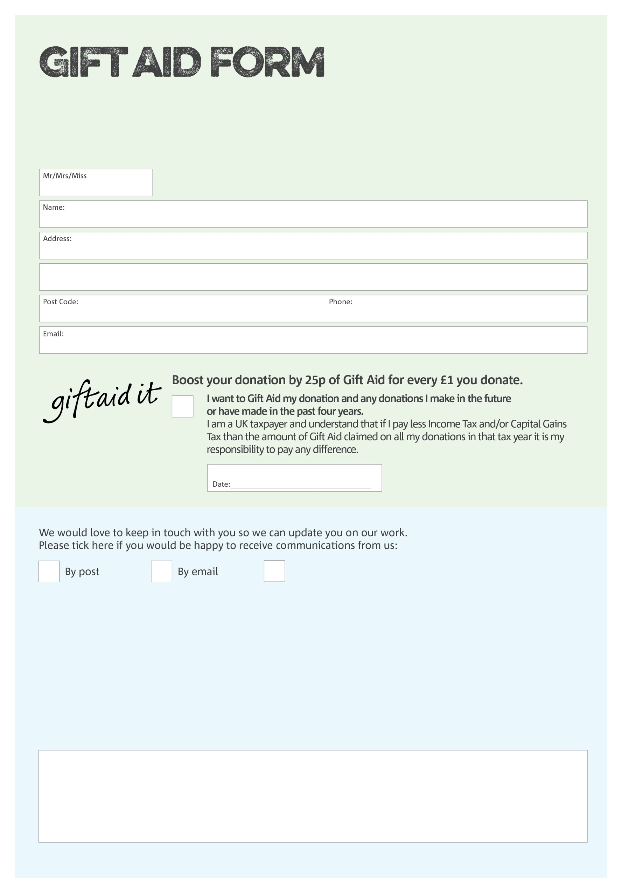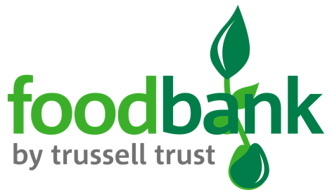

By filling in this form Thetford Foodbank will receive an extra 25p for every £1 you give at no extra cost to you. Thank you!

**Data protection**

*Thetford Foodbank is committed to protecting your privacy and will process your personal data in accordance with current Data Protection legislation. Thetford Foodbank collects information to keep in touch with you and supply you with information relating to our work. To unsubscribe from our newsletter, send a message to the email address above with the word unsubscribe in the subject line. A full data privacy statement for financial donors is available from the foodbank on request.*

You can change your preferences any time by emailing us at info@thetford.foodbank.org.uk

xxxxxx@xxxxxx.foodbank.org.uk

I do not wish to receive future communications from Thetford Foodbank

We would love to know why you have chosen to donate to *Thetford* Foodbank. If you would like to share your motivation let us know below:

Liberty Christian Family Centre, Charity Number 1090802. Registered in England & Wales